Quiz 1.1

- How many sig figs for:

- 80.1 kg
- 0.04 kg
- 240 Mg

- What is the weight of each of the objects listed in question #1 above?
a)
b)
c)

- What is the mass of 165 pounds?

- Convert the following and express the result to three significant figures.

  - 200 lb·ft to N·m
  - 350 lb/ft³ to kN/m³
  - 8 ft/h to mm/s

- What do vectors A and B add to? What is the angle of this new added-together vector from the positive x-axis?

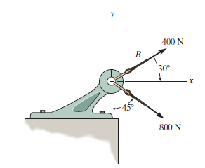
A

