Practice Exam 2

- A vertical force of 50 lb acts on the crankshaft. Determine the horizontal equilibrium force P that must be applied to the handle and the x, y, z components of reaction at the journal bearing A and thrust bearing B. The bearings are properly aligned and exert only force reactions on the shaft.

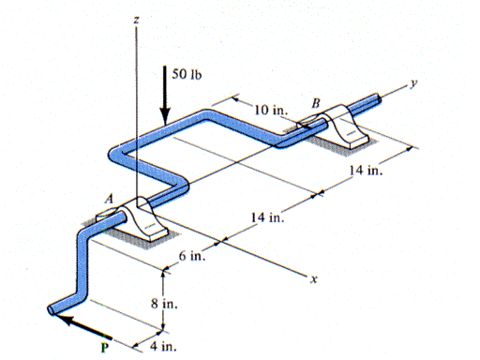

- Determine the force in each member of the truss and state if the members are in tension or compression. There is a pin connection at A and a rocker at C.
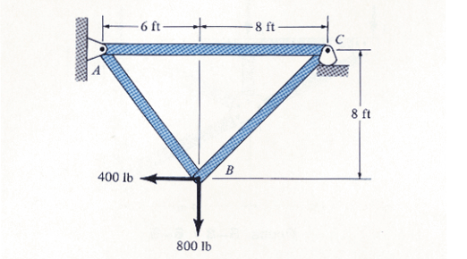

- Determine the force in members BC, FC, and FE. State if the members are in tension or compression. There is a pin connection at A and a roller at D.
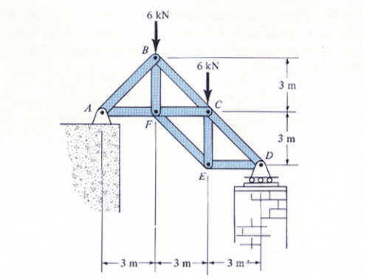

- The compound beam is supported by a rocker at B and is fixed to the wall at A. If it is hinged (pinned) together at C, determine the reactions at the supports.
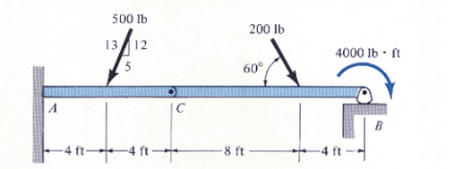

- A triangular plate is supported by a cable at A and a hinge at B. Its weight is 400 N and the material is homogeneous. Determine the tension in the cable and the loads acting on the plate at the hinge.

x
z
y
1.5 m
1.5 m
6 m

- The structure is pin connected at A and has a roller at C. Is the structure statically determinate? What would this structure be considered – a truss, frame, or machine?
