Statics Final Exam
**Draw correct free body diagrams for each problem where appropriate**

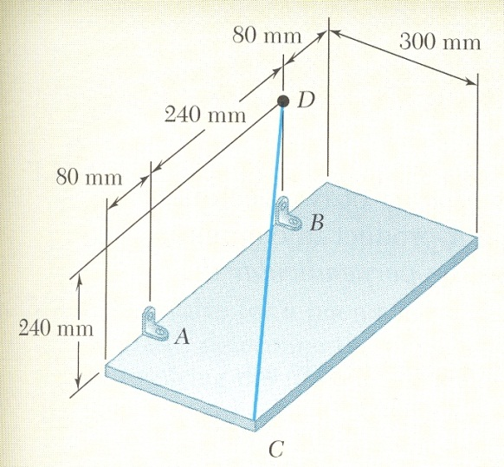
1. (10) A rectangular plate is supported by brackets at A and B and by a wire CD. Knowing that the tension in the wire is 200 N, determine the moment about A from the force of the wire CD.
z
x
y

2. (10) Find the center of mass and the centroid for the 1 cm thick composite shown below. The density of silicon is 2.33 g/cm³ and the density of gold is 19.302 g/cm³
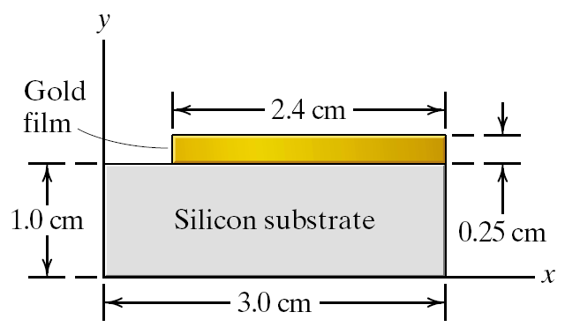

3. (10) Determine the reactions at pins D and E of the frame shown below.
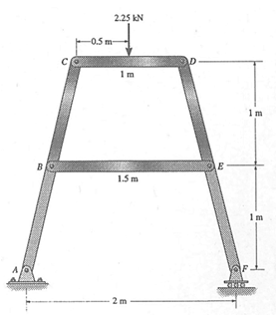

4. (10) The simply-supported beam (pin at A, rocker at B) shown below spans 16 ft and supports a uniformly distributed load of 200 lb/ft. Draw appropriate FBD and find the axial, shear, and moment bending at point C. The distance to C from the pin is 4 ft.
200 lb/ft
A
16 ft
4 ft
B
C

5. (10) Replace the existing distributed load and moment with an equivalent single resultant force. Specify the location of the resultant force along the beam as measured from A.

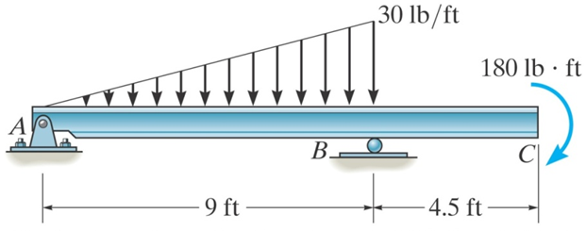

6. (10) A 100-lb force acts as shown on a 300-lb block placed on an inclined plane. The coefficients of friction between the block and the plane are µ_{s}=0.25. Determine whether the block is in equilibrium.
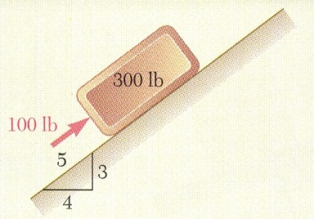

7. (10) Determine the moment of inertia of the shaded area with respect to the x-axis.
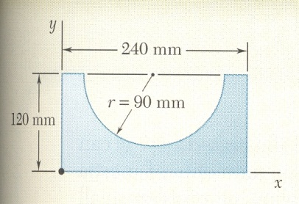

8. (3) Mark any zero-force members in the truss below.
F
F
F
9. (2) If the dot product of two vectors is zero, what does that mean? (draw a picture if you need)

10. (4) Discuss what area moment of inertia and the mass moment of inertia measure.

11. (5) Rank the tension, T, in the pulley systems shown below from highest to lowest.
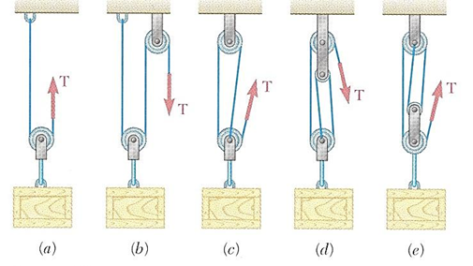
12. (4) Draw an appropriate free body diagram (FBD) of the handcart which weighs 20 lbs.
