Exam 3

1. (10 points) Draw free body diagrams for blocks A and B. Don’t worry about figuring out any values, just draw all the forces on both blocks and label them.

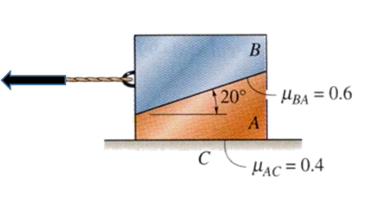

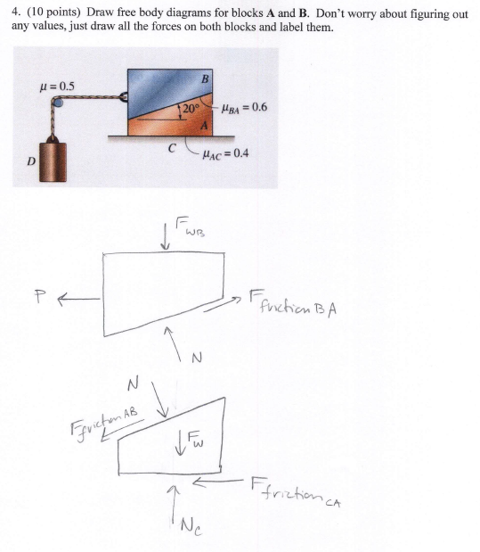

2. . (15 points) Locate the center of gravity on the archway shown below with respect to the x-y-z axis. The column-like carved parts can be considered as a rectangle shape. Exclude the light fixtures on the outside of the arch. The arch is 22 feet high and 2 feet thick. Consider the archway a homogeneous structure.

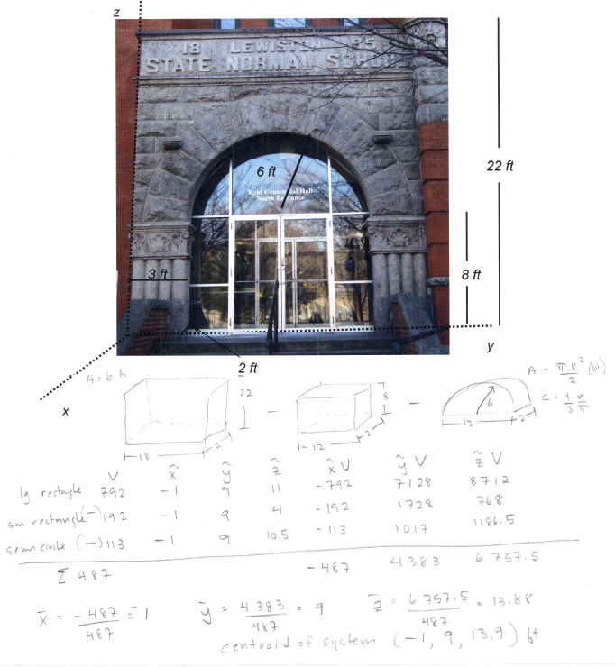

3. (15 pts) Determine the normal, shear, and bending moment at C for the frame below. The frame has a pin connection at A and a load, P, of 8 kN. The weight of the frame itself is insignificant.

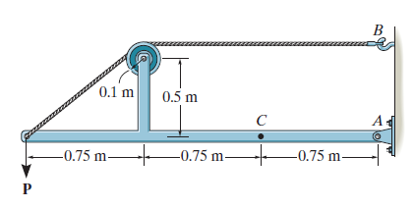

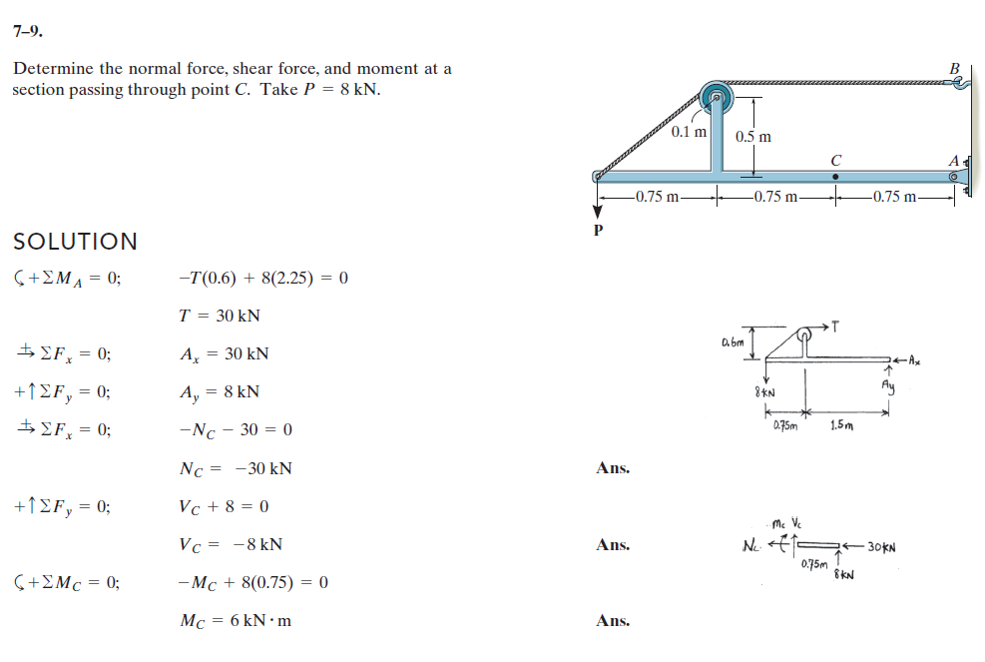

4. (6 pts) Set up the equations to find the centroid for the figure below using a vertical elemental thickness. You do not need to find the centroid, but set up the equations for finding $\overline{X, }$ $\overline{Y}$ and dA.
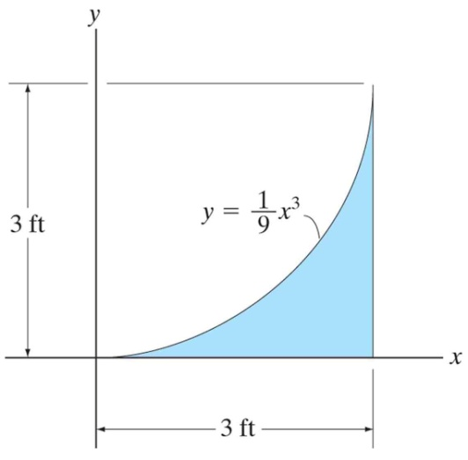

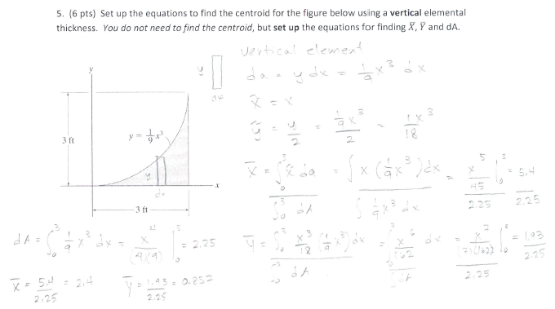

5. (6 pts) True or False:

a) ____F____ The centroid location is the same as the center of mass.
b) ____F____ The centroid is always located somewhere on the object.
c) ____T____ The center of gravity and the center of mass are the same.

6. (15) A rectangular railway tie is 6 ft x 2 ft and weighs 100 lbs. The coefficient of static friction between the railway tie and ground is µ_{s} = 0.75. To move the tie, a rope is attached to one end at a height of 1 ft above the ground. A pulling force, T, is applied at an angle of 60° as shown. Find the minimum magnitude of the force, T, that will cause either tipping or slipping.

