Exam 3

1. (10 points) Draw free body diagrams for blocks A and B. Don’t worry about figuring out any values, just draw all the forces on both blocks and label them.

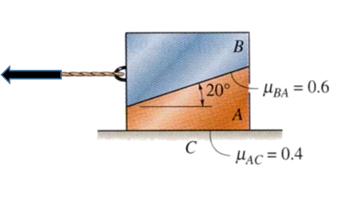

2. (15 points) Locate the center of gravity on the archway shown below with respect to the x-y-z axis. The column-like carved parts can be considered as a rectangle shape. Exclude the light fixtures on the outside of the arch. The arch is 22 feet high and 2 feet thick. Consider the archway a homogeneous structure.
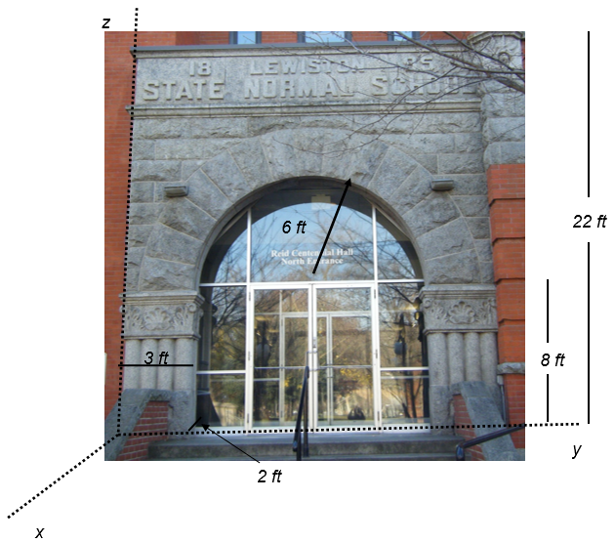

3. (15 pts) Determine the normal, shear, and bending moment at C for the frame below. The frame has a pin connection at A and a load, P, of 8 kN. The weight of the frame itself is insignificant.

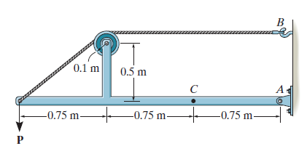

4. (6 pts) Set up the equations to find the centroid for the figure below using a vertical elemental thickness. You do not need to find the centroid, but set up the equations for finding $\overline{X, }$ $\overline{Y}$ and dA.

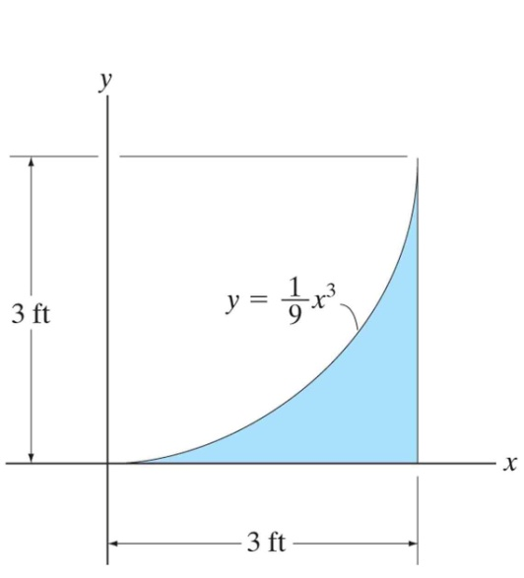

5. (6 pts) True or False:

a) ________ The centroid location is the same as the center of mass.
b) ________ The centroid is always located somewhere on the object.
c) ________ The center of gravity and the center of mass are the same.

6. (15) A rectangular railway tie is 6 ft x 2 ft and weighs 100 lbs. The coefficient of static friction between the railway tie and ground is µ_{s} = 0.75. To move the tie, a rope is attached to one end at a height of 1 ft above the ground. A pulling force, T, is applied at an angle of 60° as shown. Find the minimum magnitude of the force, T, which will cause either tipping or slipping.

