Statics
Exam 2

1. (20 pts) A weight of 200 lb hangs from a frame of negligible weight as shown. If the frame is in equilibrium, determine the support reactions at A and the force in member BD and indicate if it is in tension or compression.

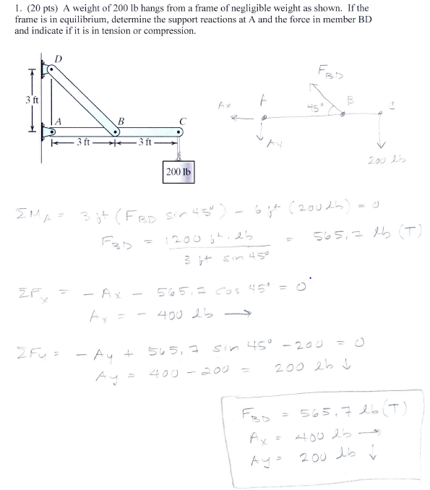

2. (20 pts) The L-shaped bar shown below is supported by a thrust bearing at A and rests on a smooth horizontal surface at B. A load of 800 N is applied at F which is 2.25 m from point C. The distance from A to C is 2 m. Calculate all the support reactions at A and B. Don’t forget to include a correct free body diagram.
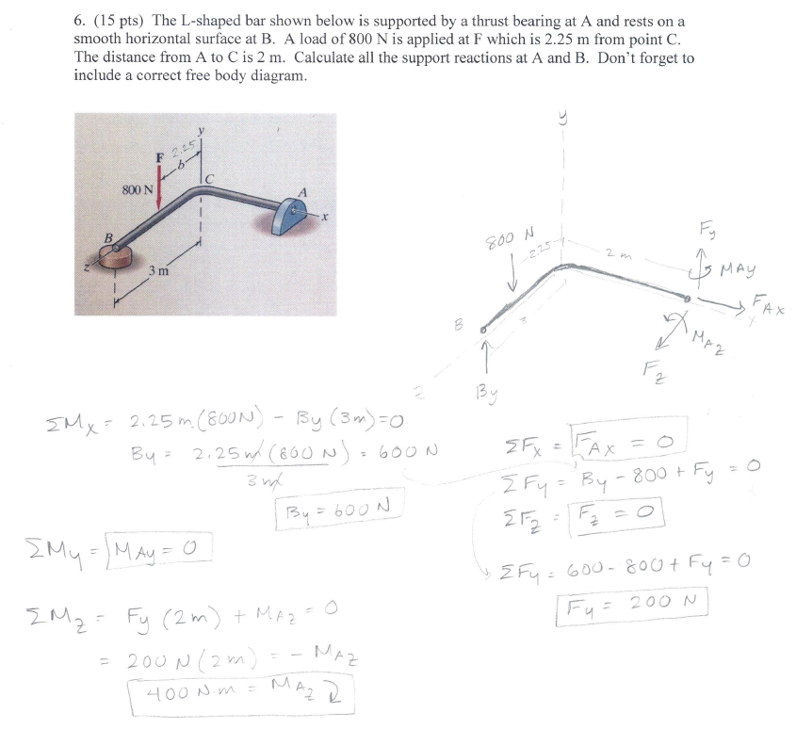

3. (9 pts) For the frame shown below, draw the free-body diagram of a) the entire frame including pulleys and cords; b) the frame without the pulleys and cords, and c) each of the pulleys.

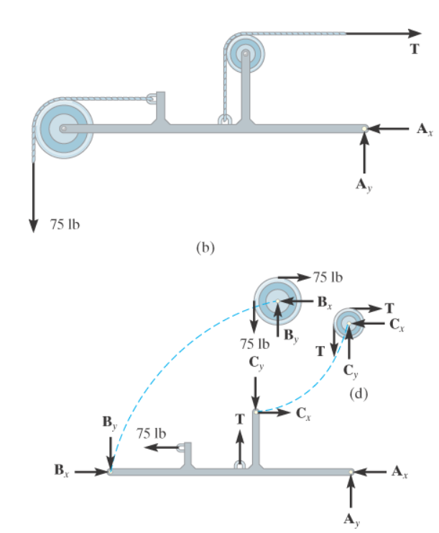

4. (5 pts) What are two things that make a truss, a truss? (verses a frame or machine)

1. made up of two-force members

2. loads ony at joints

Straight members

5. (2 pts) If a support prevents rotation of a body, then the support exerts a

__moment________________ on the body.

7. (20 pts) For the structure below: a) mark all the zero force members (with a zero on the member) and, b) find the force in member CD. Make sure to include an appropriate free body diagram for your analysis.

